# Suggestion for new

If you are new to the University of Sheffield, then this is a website dedicated to registration.

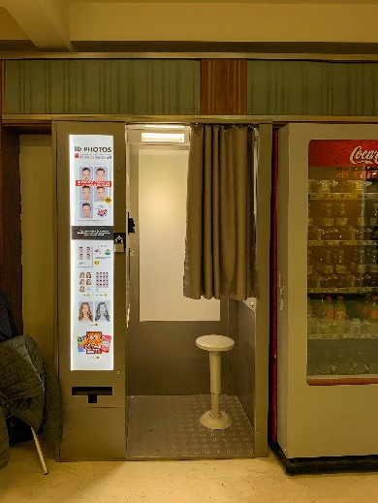

At first about all if you want to do the registration, then there are a few photos about your identity that are essential. On the L3 floor of the Student Union building you can find a machine called **Photo Booth** that will help you quickly take a photo of your ID.

After you have your own photo ID, you can go to the L6 floor to complete your registration process by confirming that your registration documents are complete.



First, you can consult **Student Support Guidance** for the steps to complete the registration. Here you can also help you solve your personal information about the university after you enter school. All in all, here is a help desk to help you with your registration.

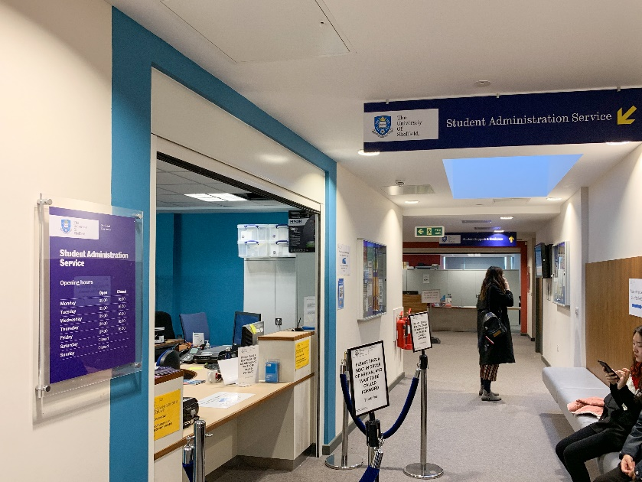

If you don't have an accident, you can complete your registration at **Student Administratration Service,** you will complete your authentication here, and go through the full process.